 | 发票日期 | 警 车 | 金额
1 | 2024.2.4 | 蒙K2750警 | 390
2 | 2024.2.5 | 蒙K2750警 | 438
3 | 2024.2.6 | 蒙K2750警 | 429
4 | 2024.2.7 | 蒙K2750警 | 421
5 | 2024.2.8 | 蒙K2750警 | 350
6 | 2024.2.9 | 蒙K2750警 | 385
7 | 2024.2.10 | 蒙K2750警 | 380
8 | 2024.2.11 | 蒙K2750警 | 415
9 | 2024.2.12 | 蒙K2750警 | 423
10 | 2024.2.5 | 蒙K3912警 | 350
11 | 2024.2.6 | 蒙K3912警 | 400
12 | 2024.2.7 | 蒙K3912警 | 410
13 | 2024.2.8 | 蒙K3912警 | 342
14 | 2024.2.9 | 蒙K3912警 | 356
15 | 2024.2.10 | 蒙K3912警 | 365
16 | 2024.2.11 | 蒙K3912警 | 437
17 | 2024.2.12 | 蒙K3912警 | 421
18 | 2024.1.31 | 蒙K5565警 | 500
19 | 2024.2.5 | 蒙K5565警 | 450
20 | 2024.2.6 | 蒙K5565警 | 500
21 | 2024.2.7 | 蒙K5565警 | 488
22 | 2024.2.9 | 蒙K5565警 | 479
23 | 2024.2.10 | 蒙K5565警 | 500
24 | 2024.2.11 | 蒙K5565警 | 500
25 | 2024.2.12 | 蒙K5565警 | 500
26 | 2024.2.1 | 蒙KWN051 | 500
27 | 2024.2.5 | 蒙KWN051 | 448
28 | 2024.2.6 | 蒙KWN051 | 446
29 | 2024.2.7 | 蒙KWN051 | 441
30 | 2024.2.9 | 蒙KWN051 | 402
31 | 2024.2.11 | 蒙KWN051 | 484
32 | 2024.2.12 | 蒙KWN051 | 460
33 | 2024.2.5 | 蒙KD615H | 345
34 | 2024.2.6 | 蒙KD615H | 400
35 | 2024.2.7 | 蒙KD615H | 385
36 | 2024.2.8 | 蒙KD615H | 300
37 | 2024.2.9 | 蒙KD615H | 310
38 | 2024.2.11 | 蒙KD615H | 300
39 | 2024.2.12 | 蒙KD615H | 400
 |  | 合计： | 16250

1.
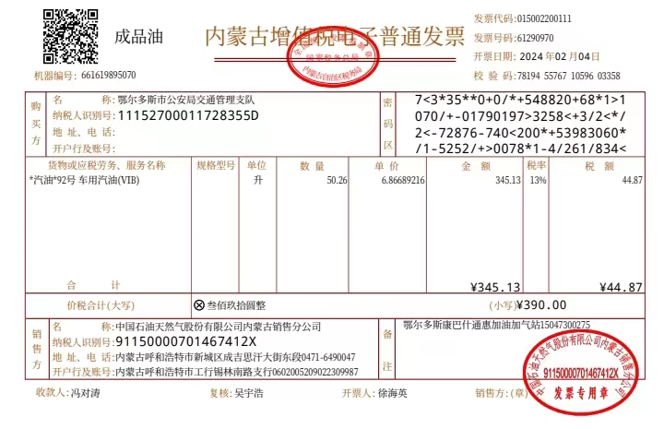

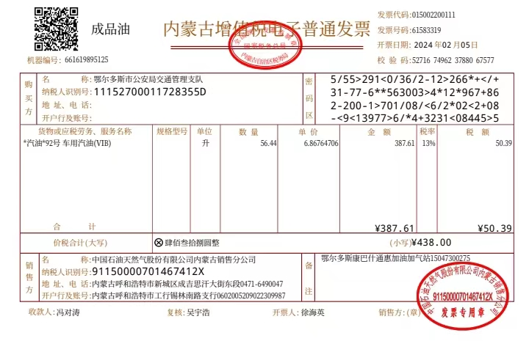

3.

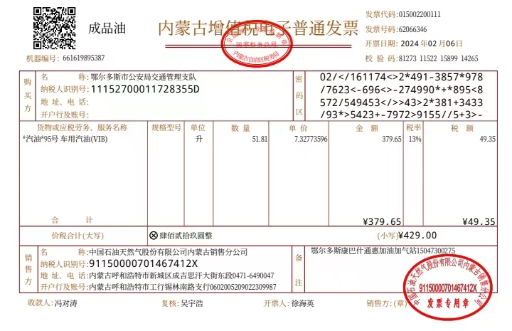

4.
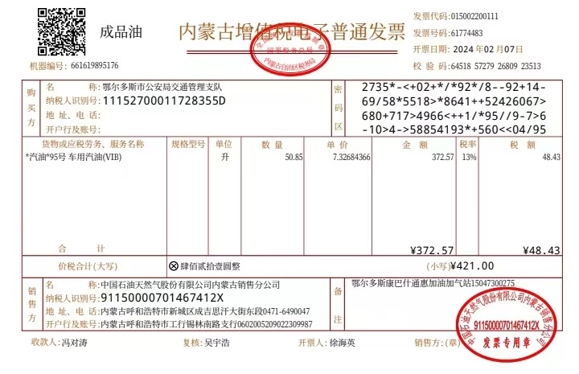

5.

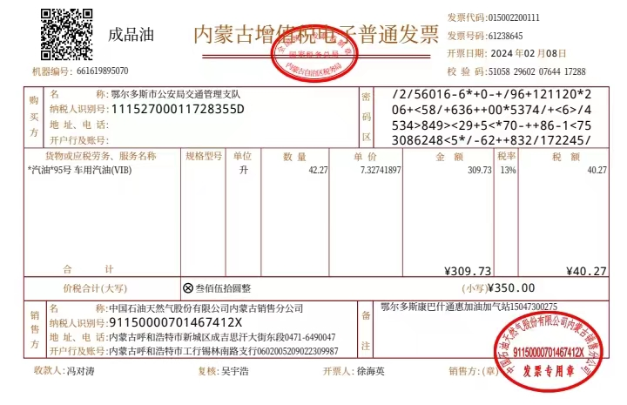

6.

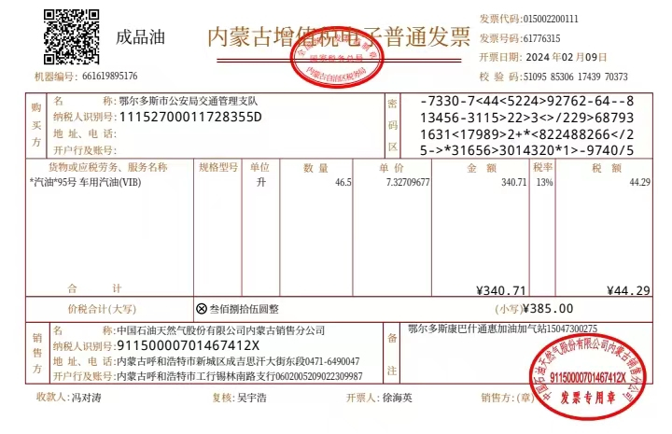

7.
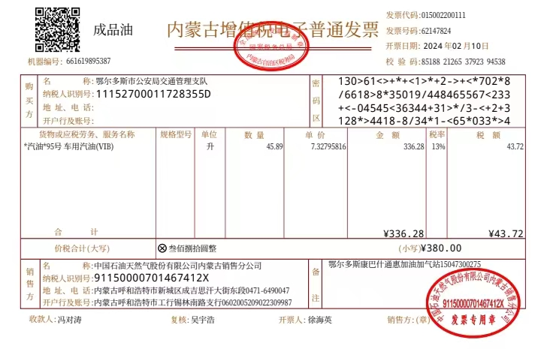

8.
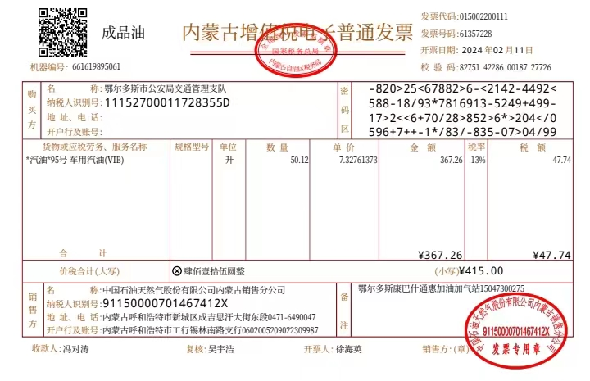

9.
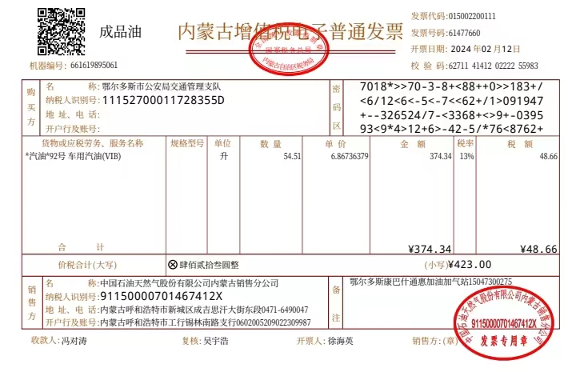

10.

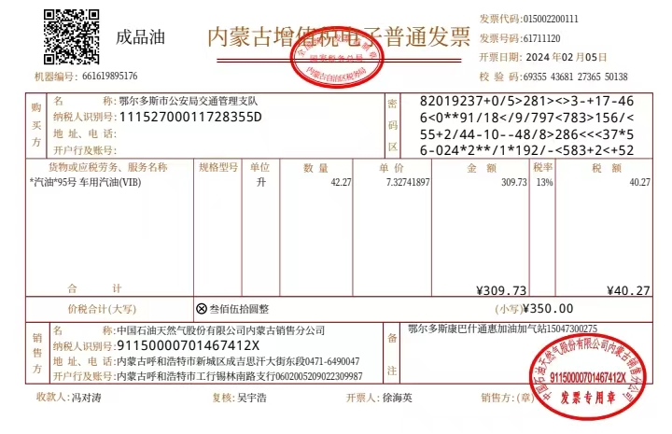

11.
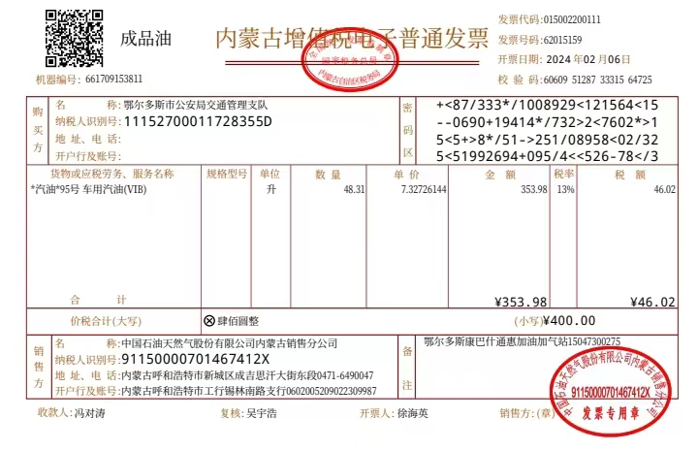

12.
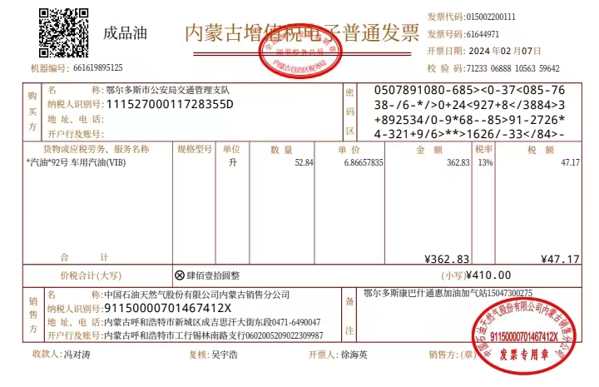

13.

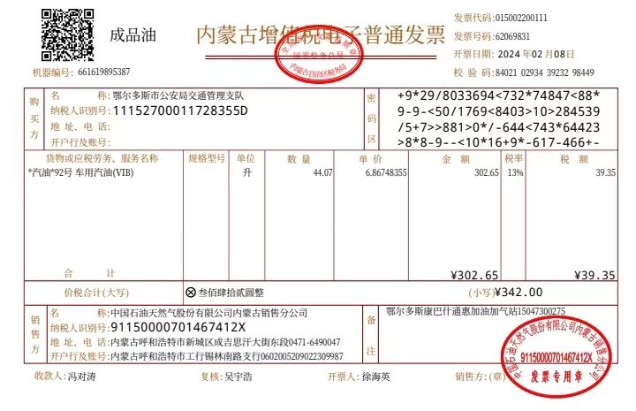

14.
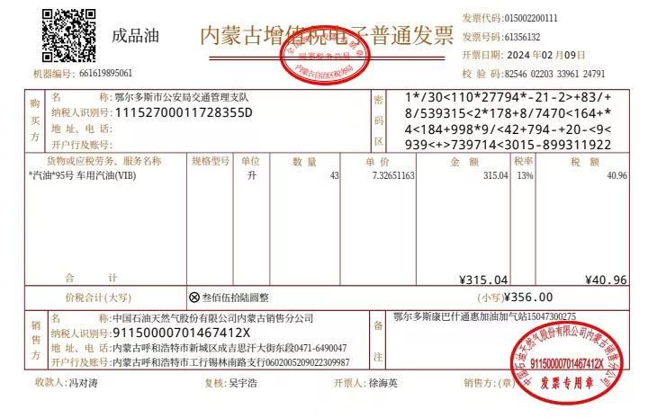

15.
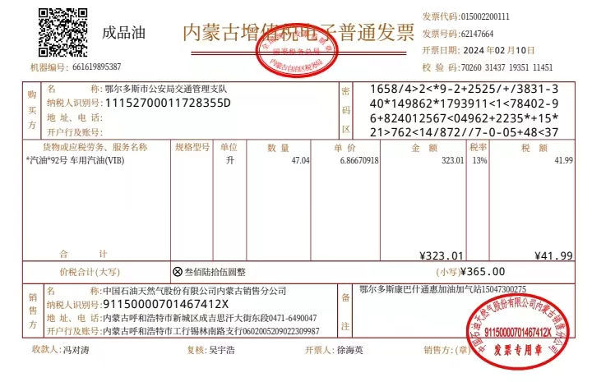

16.
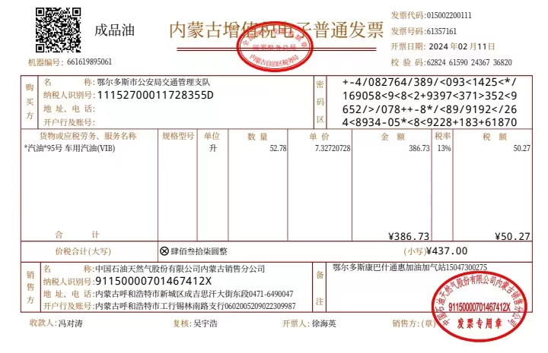

17.
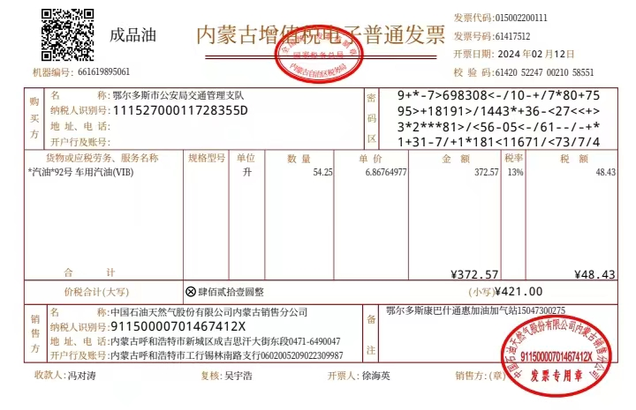

18.
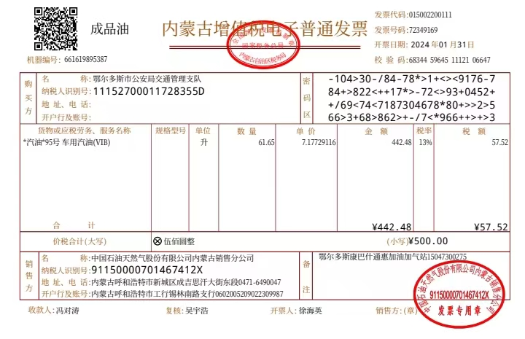

19.
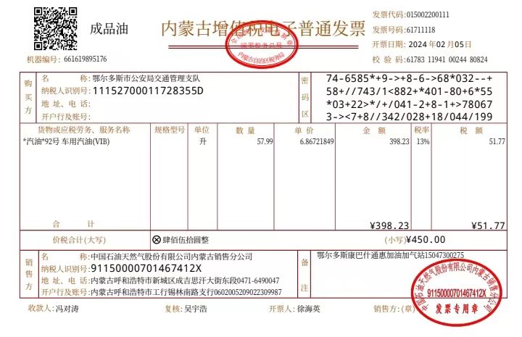

20.
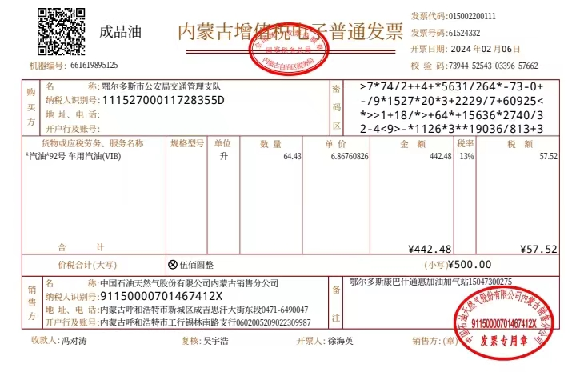

21.
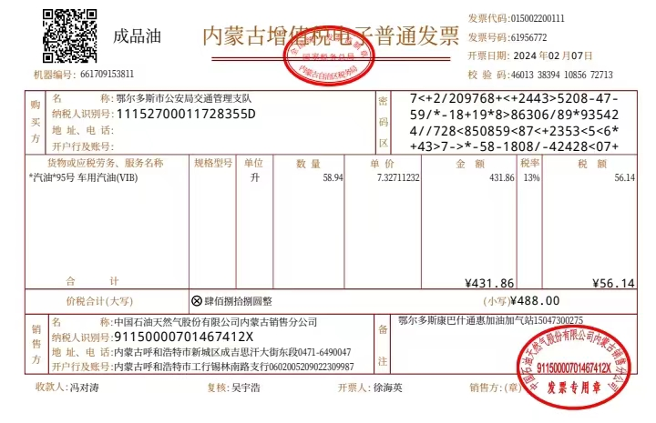

22.
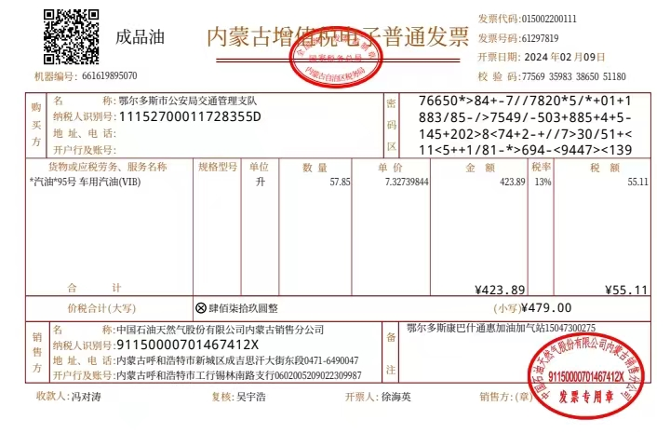

23.
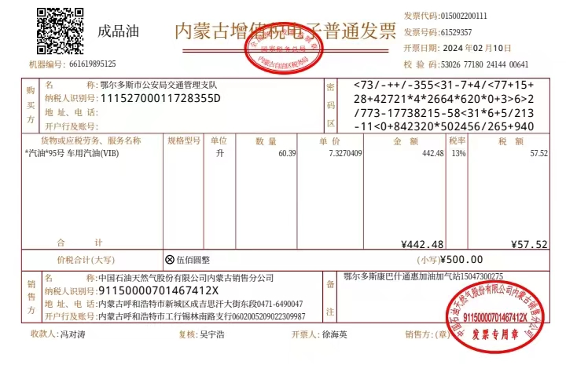

24.
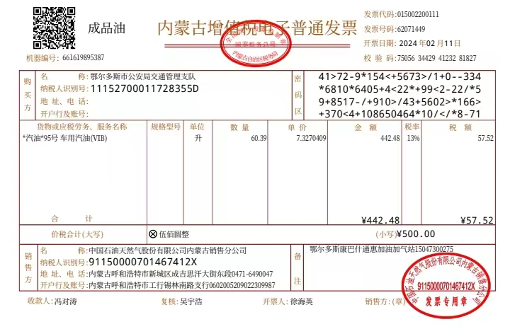

25.
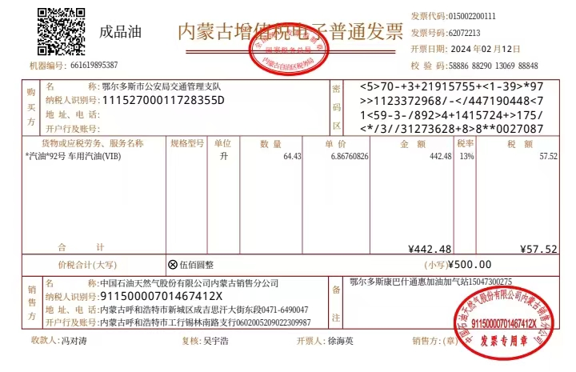

26.
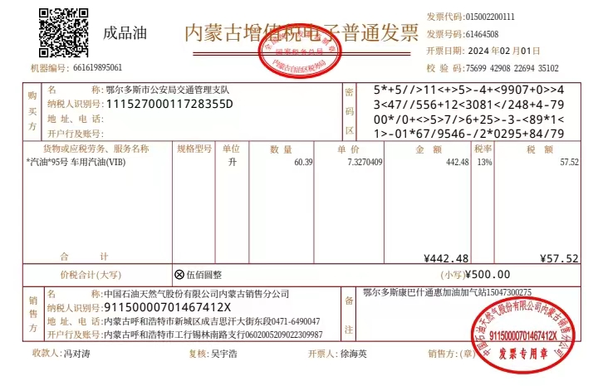

27.
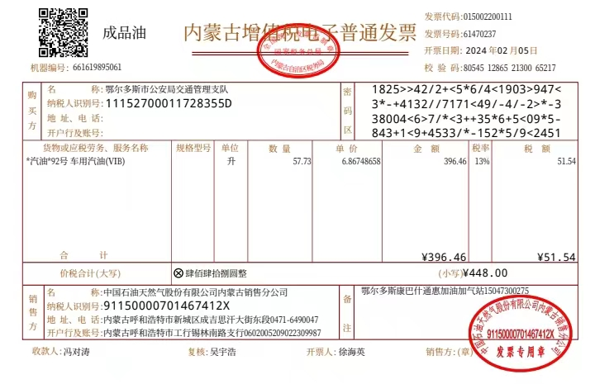

28.
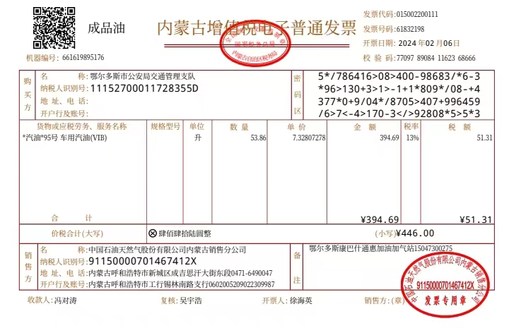

29.
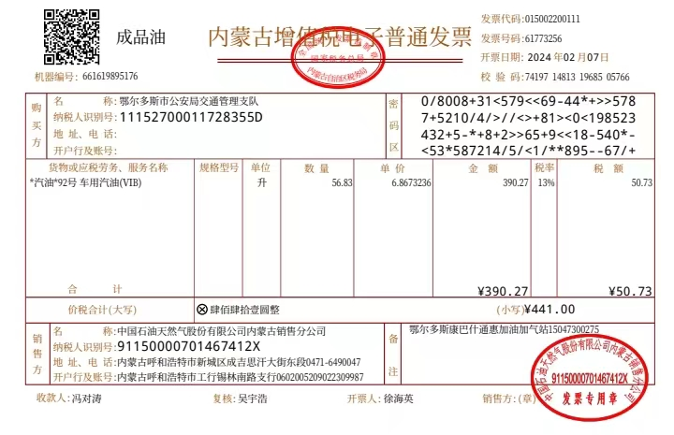

30.
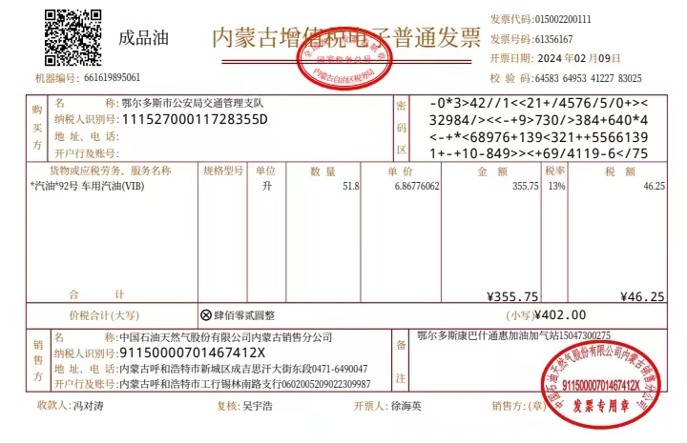

31.
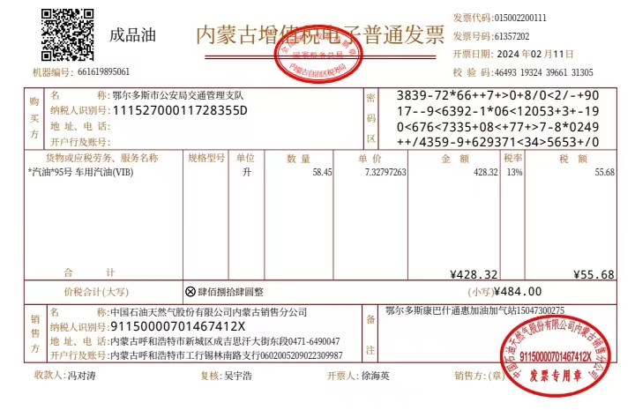

32.
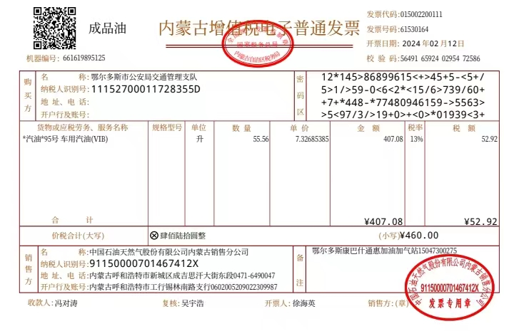

33.
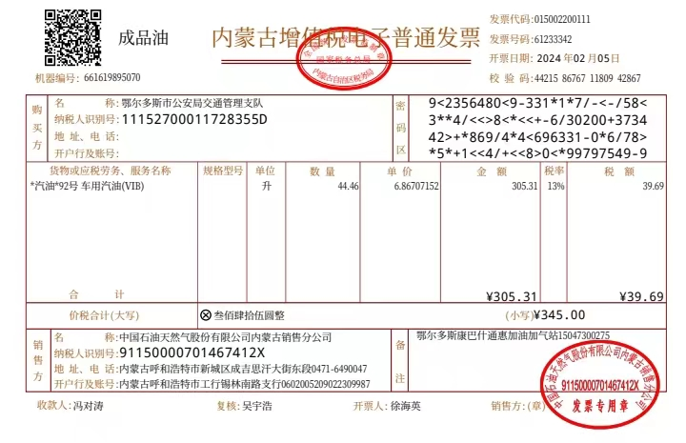

34.

35.
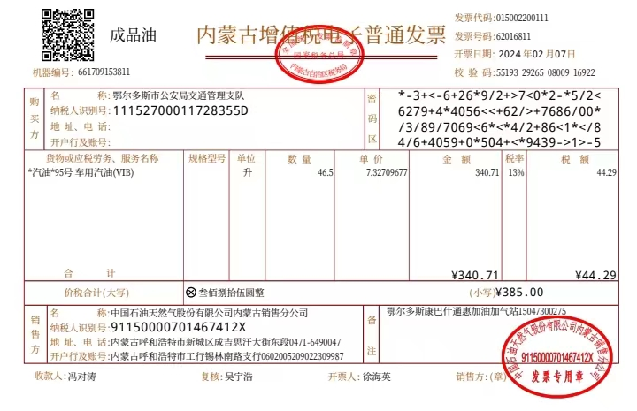

36.
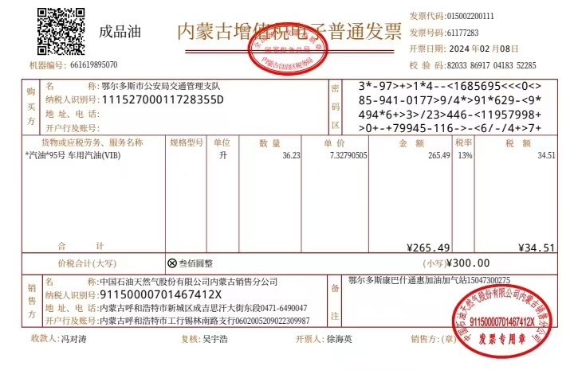

37.
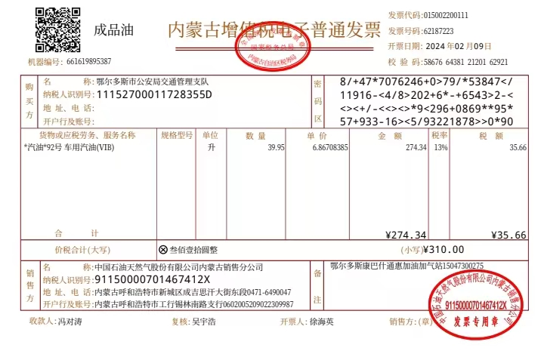

38.
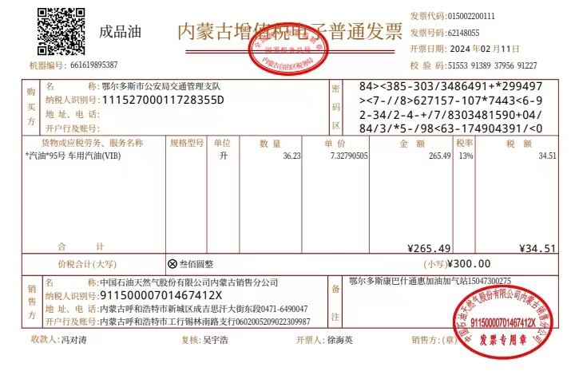

39.
